C3PR – Core &Web
Technical Specification

Duke Comprehensive Cancer Center

W
Updated Dec 12,2006 2006

Copyright Notice. Copyright 2006 Duke Comprehensive Cancer Center (“caBIG™ Participant”). caTRIP was created with NCI funding and is part of the caBIG™ initiative. The software subject to this notice and license includes both human readable source code form and machine readable, binary, object code form (the “caBIG™ Software”).
This caBIG™ Software License (the “License”) is between caBIG™ Participant and You. “You (or “Your”) shall mean a person or an entity, and all other entities that control, are controlled by, or are under common control with the entity. “Control” for purposes of this definition means (i) the direct or indirect power to cause the direction or management of such entity, whether by contract or otherwise, or (ii) ownership of fifty percent (50%) or more of the outstanding shares, or (iii) beneficial ownership of such entity.
License. Provided that You agree to the conditions described below, caBIG™ Participant grants You a non-exclusive, worldwide, perpetual, fully-paid-up, no-charge, irrevocable, transferable and royalty-free right and license in its rights in the caBIG™ Software, including any copyright or patent rights therein that may be infringed by the making, using, selling, offering for sale, or importing of caBIG™ Software, to (i) use, install, access, operate, execute, reproduce, copy, modify, translate, market, publicly display, publicly perform, and prepare derivative works of the caBIG™ Software; (ii) make, have made, use, practice, sell, and offer for sale, and/or otherwise dispose of caBIG™ Software (or portions thereof); (iii) distribute and have distributed to and by third parties the caBIG™ Software and any modifications and derivative works thereof; and (iv) sublicense the foregoing rights set out in (i), (ii) and (iii) to third parties, including the right to license such rights to further third parties. For sake of clarity, and not by way of limitation, caBIG™ Participant shall have no right of accounting or right of payment from You or Your sublicensees for the rights granted under this License. This License is granted at no charge to You. Your downloading, copying, modifying, displaying, distributing or use of caBIG™ Software constitutes acceptance of all of the terms and conditions of this Agreement. If you do not agree to such terms and conditions, you have no right to download, copy, modify, display, distribute or use the caBIG™ Software.
Your redistributions of the source code for the caBIG™ Software must retain the above copyright notice, this list of conditions and the disclaimer and limitation of liability of Article 6 below. Your redistributions in object code form must reproduce the above copyright notice, this list of conditions and the disclaimer of Article 6 in the documentation and/or other materials provided with the distribution, if any.
Your end-user documentation included with the redistribution, if any, must include the following acknowledgment: “This product includes software developed by Duke Comprehensive Cancer Center.” If You do not include such end-user documentation, You shall include this acknowledgment in the caBIG™ Software itself, wherever such third-party acknowledgments normally appear.
You may not use the names “Duke Comprehensive Cancer Center”, “The National Cancer Institute”, “NCI”, “Cancer Bioinformatics Grid” or “caBIG™” to endorse or promote products derived from this caBIG™ Software. This License does not authorize You to use any trademarks, service marks, trade names, logos or product names of either caBIG™ Participant, NCI or caBIG™, except as required to comply with the terms of this License.
For sake of clarity, and not by way of limitation, You may incorporate this caBIG™ Software into Your proprietary programs and into any third party proprietary programs. However, if You incorporate the caBIG™ Software into third party proprietary programs, You agree that You are solely responsible for obtaining any permission from such third parties required to incorporate the caBIG™ Software into such third party proprietary programs and for informing Your sublicenses, including without limitation Your end-users, of their obligation to secure any required permissions from such third parties before incorporating the caBIG™ Software into such third party proprietary software programs. In the event that You fail to obtain such permissions, You agree to indemnify caBIG™ Participant for any claims against caBIG™ Participant by such third parties, except to the extent prohibited by law, resulting from Your failure to obtain such permissions.
For sake of clarity, and not by way of limitation, You may add Your own copyright statement to Your modifications and to the derivative works, and You may provide additional or different license terms and conditions in Your sublicenses of modifications of the caBIG™ Software, or any derivative works of the caBIG™ Software as a whole, provided Your use, reproduction, and distribution of the Work otherwise complies with the conditions stated in this License.
THIS caBIG™ SOFTWARE IS PROVIDED "AS IS" AND ANY EXPRESSED OR IMPLIED WARRANTIES (INCLUDING, BUT NOT LIMITED TO, THE IMPLIED WARRANTIES OF MERCHANTABILITY, NON-INFRINGEMENT AND FITNESS FOR A PARTICULAR PURPOSE) ARE DISCLAIMED. IN NO EVENT SHALL THE DUKE COMPREHENSIVE CANCER CENTER OR ITS AFFILIATES BE LIABLE FOR ANY DIRECT, INDIRECT, INCIDENTAL, SPECIAL, EXEMPLARY, OR CONSEQUENTIAL DAMAGES (INCLUDING, BUT NOT LIMITED TO, PROCUREMENT OF SUBSTITUTE GOODS OR SERVICES; LOSS OF USE, DATA, OR PROFITS; OR BUSINESS INTERRUPTION) HOWEVER CAUSED AND ON ANY THEORY OF LIABILITY, WHETHER IN CONTRACT, STRICT LIABILITY, OR TORT (INCLUDING NEGLIGENCE OR OTHERWISE) ARISING IN ANY WAY OUT OF THE USE OF THIS caBIG™ SOFTWARE, EVEN IF ADVISED OF THE POSSIBILITY OF SUCH DAMAGE.

Development Team(s)
Development | Technical Documentation | Program Management
Kruttik Aggarwal² | Manav Kher² | Bob Annechiarico¹
Manav Kher² | Priyatam Mudivarti² | Jamie Cuticchia¹
Priyatam Mudivarti² |  | Patrick McConnell¹
Ram Chilukuri² |  | Ram Chilukuri²
Ramakrishna Gundala²
¹Duke Comprehensive Cancer Center | ²Semantic Bits

Contacts and Support
Enter training contact | Patrick McConnell (patrick.mcconnell@duke.edu)
Enter customer support contact | NA

LISTSERV Facilities Pertinent to software teams
LISTSERV | URL | Name
c3prv2-elaborator | c3prv2-elaborators@gforge.nci.nih.gov | C3PR Elaborators Forum
C3prv2-general | c3prv3-general@gforge.nci.nih.gov | C3PR General Forum
C3prv2-developers | c3prv2-developers@gforge.nci.nih.gov | C3PR Developers Forum

Table of Contents

Table of Contents 6
1 Scope & Purpose 7
2 Overview 7
2.1 Technology Stack 7
2.2 Core Modules 8
2.2.1 Domain Object Layer 8
2.2.2 Views 8
2.2.3 Controllers 8
2.2.4 Commands 8
2.2.5 Service Layer 8
2.2.6 Persistence Layer 8
2.2.7 Utilities 9
3 Domain and Analysis Model 10
4 Implementation Model 11
5 Data Model 12
6 Use Case Realization 12
6.1 Create a Study (Protocol) 12
6.1.1 Activity diagram 12
6.1.2 Sequence diagram – core/web 12
7 Integration / External Systems 12
7.1 ESB Client 12
8 Unit Testing 13
8.1 JUnit 13
8.2 Spring Mock Objects 13
8.3 Generic Classes 13
9 Integration Testing 13
10 Configuration/Build/Deployment 13
Documentation /Artifacts 14

Scope & Purpose
The scope of this document is to provide technical design / specification, for the Core & Web project modules within C3PR v2. The specification will include the use case realizations within each iteration with accompanying UML models and documentation wherever appropriate.
The purpose of this document is to facilitate development with an initial phase of analysis and design and support as a documentation of the overall design in the Core project for other developers

Overview
C3PR Core project consists of the core modules for overall project like domain objects, service layer classes, data access (dao), db scripts, util classes and shared libraries servicing the entire project. The project is build separately and is included as a dependency for other projects. Although the Core project cannot be deployed as an application itself, it can packaged in a separate jar to include in your project’s classpath.

Technology Stack
Operating System | Windows XP/Linux
Java Version | JDK 5.0
MVC framework | Spring MVC 2.0
View Technology | JSP, Tag libraries, Ajax
Ajax Framework | <not yet finalized>
ORM | Hibernate 3.2.1
Transactions, IOC, dependency injection | Spring 2.0
Web Server | Tomcat 5.5.20
Database | Oracle 9i / PostgreSQL/MySQL
Development Tools | Eclipse 3.2/JBoss IDE 2.0, Enterprise Architect 4.5
Build | Ant
Source Control | CVS (gForge)

The view technology incorporated in C3PRv2 consists of jsp pages, css, Ajax and tag libraries included from spring.

Core Modules

Domain Object Layer
C3PRv2 has a domain driven design with analysis starting from a Bridge Harmonized model. A set of domain objects will be created in edu.duke.cabig.c3pr.domain. Once domain model is finalized, an immediate Implementation Model is based out of the domain model which identifies the Java classes, associations. The same domain objects are persisted using Hibernate and Hibernate 3 annotations will be used for mapping to database elements instead of separate hbm files. These annotations can in turn be configured via Spring’s bean configuration files

Views
Spring’s MVC is being used as the de facto MVC architecture for C3PRv2. All the Controller classes for the respective use case will be located in the package edu.duke.cabig.c3pr.web

Controllers

Commands
A set of command objects (Form objects) as per the Spring MVC which acts as a command for each controller
The service layer will expose a set of interfaces for the client to call in (currently the interface decided is a Web Interface). The Controller classes typically delegate the functionality to Service classes. Spring adds the dependency injection for the implemented classes as Controller need not be coupled with the sam

Service Layer
DAO interface and implementations will be created to facilitate database access. The application will only access the database via a DAO interface object. Each implementation of the dao interface would a specific implementation (in this case, hibernate) which extend the org.springframework.orm.hibernate3.support.HibernateDaoSupport class that provides a good template for quickly building data access methods without the risk of database leaks and poor error handling.

Persistence Layer

Utilities
Several Utility classes for supporting springmvc framework like propertyEditors, tag libraries, email, xml marshalling, string etc are included in this package, etc

Domain and Analysis Model
The Domain and Analysis model for C3PR is based on a harmonized model, BRIDGE. For a complete UML model, refer the C3PRv2-Bridge in appendix
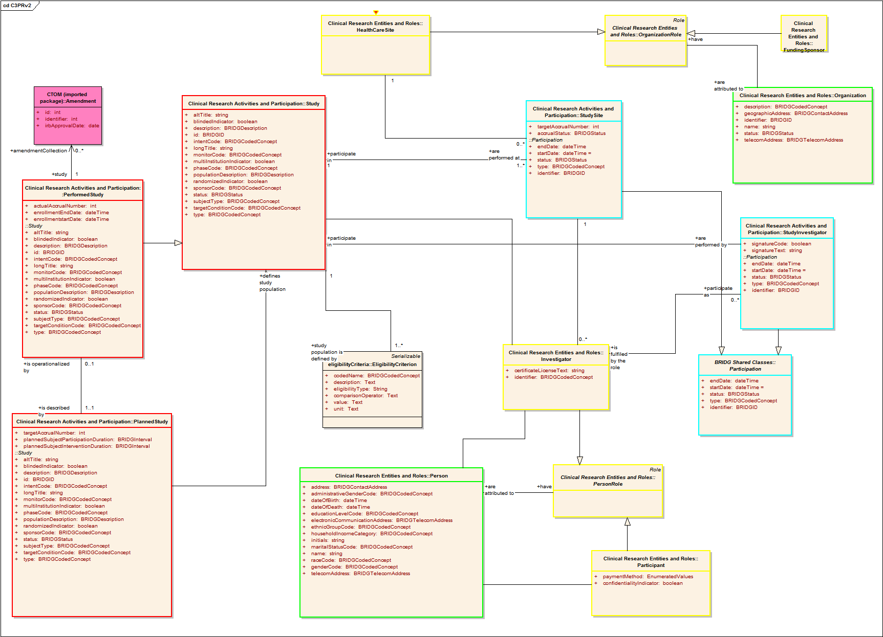

Implementation Model
Derived from Domain Analysis model, the implementation model is a model realized for a Java implementation with classes, associations. For a complete UML model, refer the Domain model section in c3pr-uml design in appendix
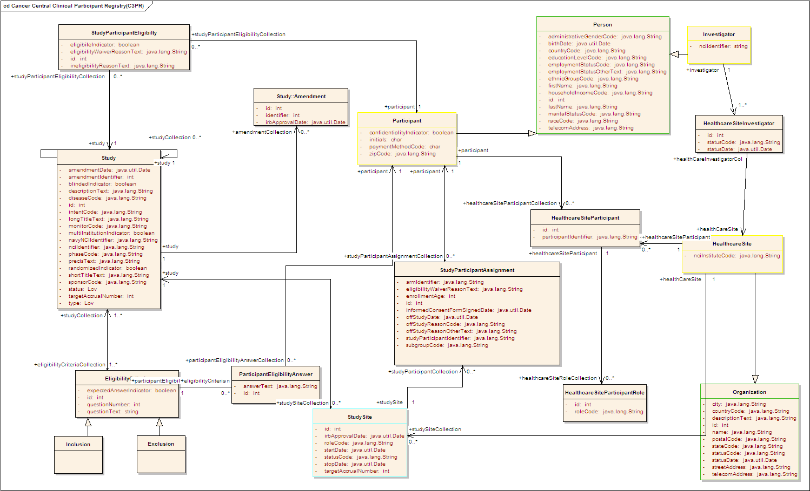

Data Model
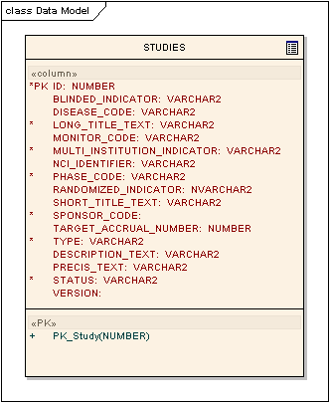

Use Case Realization
This use-case deals with the manual creation of a study by entering each data element of the study

Create a Study (Protocol)
For this iteration, the complexity is minimal and involves in the creation of a basic Study domain object along with the integration with ESB client interface to add an asynchronous message. ServiceMix and GridServices are used to propagate the newly created Study

Activity diagram
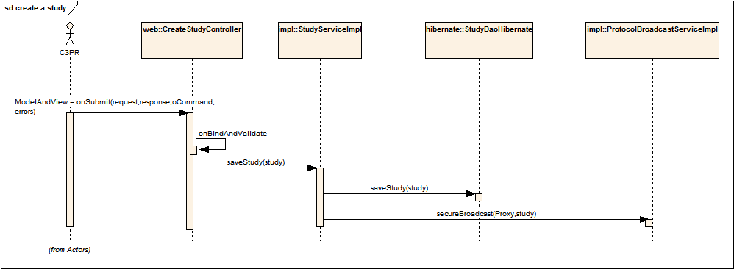

Sequence diagram – core/web
For a complete UML model, refer the Analysis Model section in c3pr-uml design in appendix

Integration / External Systems
C3PR Service layer would be interacting with an ESB client for messaging to pass on the data created (new Study, registration etc) to other applications/system?. More information about the design of esb can be found in the technical design of esb

ESB Client

Unit Testing
JUnits will be used for unit testing individual components.

JUnit
Use of Spring mock objects for mocking the dependent layers

Spring Mock Objects
A set of generic JUnit Test cases will be written for each layer to expedite the unit testing across each layer.

Generic Classes

Integration Testing

Integration Testing will be achieved via JUnit/Haste frameworks. This is integrated with the main build file

Configuration/Build/Deployment
The files in the Core/Web projects will be build through the main build file (build-core & build-web individually). For all other builds like build-tests, the individual build files of these projects have corresponding ant tasks
- References

Documentation /Artifacts
SI No | Artifact | Type | Link
1 | GForge CVS Repository | CVS Repository | gforge.nci.nih.gov
2 | c3pr_uml.eap | UML Design
3 | C3PRv2-Bridge.EAP | Domain Model | gforge.nci.nih.gov
4 | C3prv2_use_cases.doc | Use Cases | gforge.nci.nih.gov
5 | c3prv2_technical_architecture.doc | Architecture | gforge.nci.nih.gov
6 | C3prv2_srs.doc | SRS | gforge.nci.nih.gov
7 | c3prv2_technical_spec_servicemix.doc | design | gforge.nci.nih.gov

- Glossary
Term | Definition
C3PR | Cancer Central Clinical Participant Registry
API | Application Programming Interface
GUI | Graphical User Interface
UML | Unified Modeling Language

